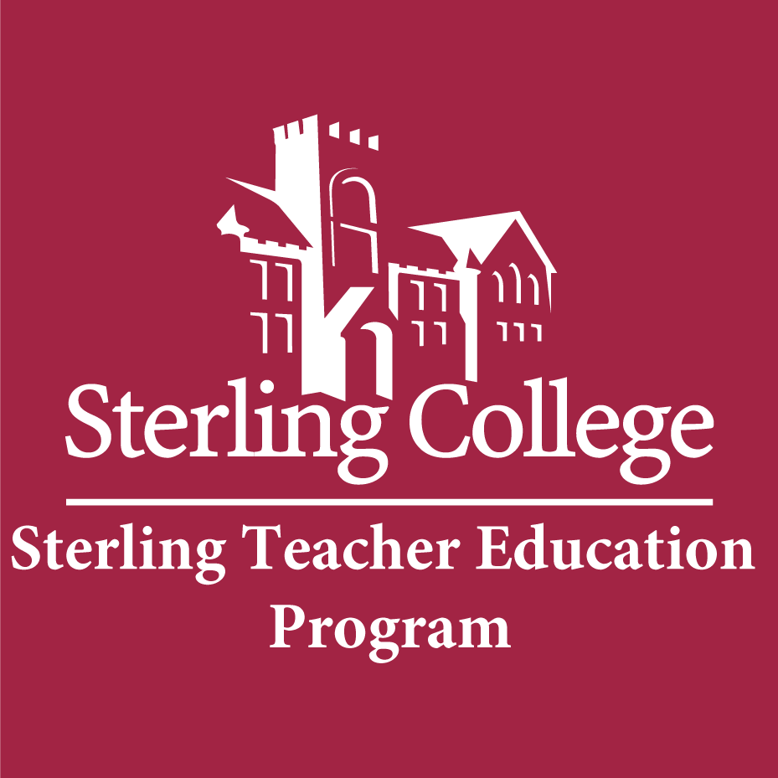 STEP DECLARATION OF CANDIDACY APPLICATION

- Name __________________________________Date_______________AY________

- Current Status: ___Undergraduate ___Graduate
If graduate: __Degree-seeking __Licensure only

- Interest Area: __Elementary (K-6) __Secondary (7-12) __Art/Music/ExSci (PreK-12)

Secondary Major Area: _______________________

- High Incidence Special Education Area: __ (K-6) __ (6-12) __(PreK-12)

- Projected Clinical Teaching Experience semester: ___Semester _____Year

- Check the most appropriate category for race/ethnicity:

__Alaskan Native
__American Indian
__Asian
__Black/African American
__Hispanic/Latino of any race
__Native Hawaiian
__Other Pacific Islander
__Two or More Races
__White/Caucasian
__Prefer Not to Answer

- Answer the questions on page two. These questions that will be asked by the state when you apply for licensure. Some may prevent you from obtaining a Kansas State Teaching License.

- Submit this application and contract to STEP Administrative Assistant.

_________________________________________ ___________________________
(Student’s Signature) (Date)

FOR ADMINSTRATIVE USE:

ACCEPTED BY THE TEACHER EDUCATION COMMITTEE Academic Year _________

_________________________________________ ___________________________
(Teacher Education Committee Chair) (Date)

STEP DECLARATION OF CANDIDACY APPLICATION page 2
Kansas State Department of Education (KSDE), Licensure Questions

a. Have you ever been convicted of a felony?
NO YES

b. Have you ever been convicted of ANY crime involving theft, drugs, or a child?
NO YES

c. Have you entered into a criminal diversion agreement after being charged with any offense described in question a or b?
NO YES

d. Are criminal charges pending against you in any state involving any of the offenses described in question a or b?
NO YES

e. Have you had a teacher’s or school administrator’s certificate or license denied, suspended, revoked or been the subject of other disciplinary action in any state?
NO YES

f. Is disciplinary action pending against you in any state regarding a teacher’s or administrator’s certificate or license?
NO YES

g. Have you ever been disbarred or had a professional license or state issued certificate denied, suspended, revoked or been the subject of other disciplinary action regarding any profession in Kansas or any other state?
NO YES

h. Have you ever been terminated, suspended, or otherwise disciplined by a local Board of Education for falsifying or altering student tests or student test scores?
NO YES

i. Have you ever falsified or altered assessment data, documents, or test score reports required for licensure?
NO YES

STEP DECLARATION OF CANDIDACY CONTRACT

I understand the following requirements must be met prior to acceptance to the Sterling Teacher Education Program (STEP):

- Declare Candidacy by completing the Declaration Packet available in STEP’s Administrative Assistant’s Office
- Demonstrate Pre-Professional Skills:
- Option 1: ACT Test with minimum scores of

4.0 A TARGET
3.7 A-______________
3.3 B+ COMPETENT
3.0 B
2.7 B-___________________
2.3 C+ BASIC
2.0 C____________________
1.7 C- UNACCEPTABLE
1.3 D+
1.0 D
0.7 D-
0.0 F

- Reading - 22
- Math - 22
- Option 2: SAT Test with minimum scores of
1. Reading - 544
2. Math - 533
- Option 3: Praxis CORE with minimum scores of
- Reading – 169
- Math – 163
- Writing – 165
- Option 4: Core Competency Based Grades: Candidates must complete the core competency courses listed below with the noted grades within their first year of enrollment. Candidates, who complete an AP of CLEP exam(s) to meet requirement(s), will be reviewed by the Education Department Chair and the Registrar to determine if competency grade has been achieved
- LL101 College Composition C or higher
- GE Literature Course C or higher
- GE Mathematics Course C or higher
**Candidates may mix and match options 1-4 to meet the pre-Professional skills requirements.
- Option 5: Post Baccalaureate GPA of 3.0 or higher and Praxis II Content Test with passing score
- Complete CM101 Public Speaking with a B of higher.
- Complete ED195 Introduction to Education with a B or higher
- Complete Level I Professional Coursework with a C or higher – unless required grade is stated.
- Maintain an overall GPA of 3.0 or higher.
- Successful completion of 40 field hours.
- Dispositions from department.
- Portfolio.

I understand that in order to proceed in STEP Level II, & III Professional and Methods Classes and STEP Level IV Clinical Teaching:

- I must maintain at least the following: 2.75 in my overall grade point average
- I must complete a portfolio with all required information to present to STEP when the above requirements are completed in order to be accepted to STEP.
- I must complete all my professional education courses with a grade of C or higher unless another grade is stated.
- Elementary majors must complete all content education courses with a grade of C or higher.

_______________________________________________
(Teacher Candidate Print)

________________________ _______________________ _____________________
(Teacher Candidate Signature) (Date)

